Consistent Energy Debt: America's Unequal Power Grid

Emma Delehanty, Mukila Rajasekar, John Tomaselli

University of North Carolina Wilmington

Consistent Energy Debt:  
America's Unequal Power Grid

Electricity is not local in the United States (U.S.). This report details how authorities responsible for controlling and monitoring local electrical supply produce varying amounts of electricity, sometimes importing from neighbors to cover deficits. These imports are needed as demand fluctuates in each region and subregion based on the hour, day, week, month, and season. Modest evidence exists that the more successful electrical regions and subregions tend to use more environmentally friendly sources of power. In support of spreading this trend, we articulate the patters described above as well as identify broad locations in which additional supplies of renewable energy sources can be installed to help balancing current regional energy deficits.

**Project Background**

**Project Purpose and Investigation Method**

Our project’s purpose is to identify regions of the Continental U.S.’ electrical grid that would most benefit from supplementary power generation sources. Several reasons present themselves as incentives for the above. First, weaknesses in the rhythm of power generation could cause unintentional harm to customers.  A recent article from Bloomenergy estimates a 5 million U.S. dollar loss for every hour of electrical downtime suffered by large manufacturers in the U.S. (Hussein, 2019). As the same article claims that 28% of U.S. manufacturers lose power monthly, this trend can quickly cut into a business’ profit margins. Second, we wish to understand the degree of interconnectedness between regions, possibly indicating the range of any power disruptions.  Finally, we want to provide evidence supporting clean energy implementation in less resilient areas of the U.S. power grid. When complete, our project will address each of the above reasons, providing the information needed to make the overall network more resilient.

We plan to address our purpose through a thorough investigation of total power generation and demand in different regions of the Continental United States.  Data available from the U.S. Energy Information Administration (EIA) specifies power variables at the Balancing Authority (BA), or subregion, level (U.S. Energy Information Administration, 2019).  Supplemental solar and wind energy data is also accessible at the U.S. Department of Energy’s National Renewable Energy Laboratory (National Renewable Energy Laboratory, 2019). Using these resources, we first ask which BAs exhibit negative interchanges during the hours of a day, the days of the week, and different seasons. Next, our investigation looks at the top 10 BAs with positive interchanges and the top 10 BAs with negative exchanges. These BAs are compared in terms of their overall demand, excess or deficient capacity, and their favored energy generation sources. We then examine the top 5 BAs and regions for each available energy generation source. In regions with more than one balancing authority, we further study the overall pattern of positive or negative interchanges for any obvious patterns. Completing our 5 standard questions, we ask how energy production from specific energy sources fluctuate throughout each day, week, and month. As a sixth and final bonus question, our research identifies specific regions with consistent negative interchanges that have high potential for supplemental solar or wind energy installation. The compilation of answers from the above questions comprehensively addresses the issue’s scope as well as stipulates where and how to place preferred solutions.

Before addressing those solutions, some definitions are needed to place our investigation into context. A Mega Watt (MW) hour, the standard unit of measure used throughout this investigation, is equivalent to the same amount of electricity as consumed by 330 homes in an hour, on average (DigitalGreenMedia, LLC, 2010). MW hours are tracked by BAs, the entities responsible for balancing the supply and demand of electricity within their individual power grids (U.S. Energy Information Administration, 2019). These authorities exchange excess power or obtain needed power with adjacent BAs in real-time. Generally, several BAs aggregate into power regions, providing middle-management of BAs for a wider geographic area. Whether BAs are singular power generation sources or cooperatives between multiple power generation sources, they usually service a customer base in a set area. Generation-only BAs, who only generate electricity for exchange with other BAs and who do not have a customer base, do exist and we address their impact later in this paper (U.S. Energy Information Administration, 2018).

How BAs monitor their electrical consumption and need is precisely defined. The EIA specifies net generation as the “…metered output of electric generating units in the BA’s electric system (U.S. Energy Information Administration, 2019).” This generation only includes generating units that are managed by the BA or whose operations are visible to the BA. Independent power generation operations not consistently connected to the wider power grid are not included in the net generation calculation.  Interchange between BAs is defined as the, “…net metered tie line flow from one BA to another directly interconnected BA (U.S. Energy Information Administration, 2019).” Extending this definition, total net interchange is the net sum of all interchange occurring between a BA and its directly interconnected neighboring BAs.  Negative interchange values indicate net inflow or importation of electricity. Likewise, positive interchange values indicate net outflow or exportation of electricity. The definition of demand is derived from the above definitions as net generation minus total interchange. Being a derived definition means that demand, contrary to one’s intuition, can be both positive or negative. Without explicit guidance in the EIA’s documentation, we presume that negative demand occurs when power consumers, such as homes or business, produce electricity and provide excess capacity to the BA. An example of this exchange is when excess electricity generated by a home’s solar panels is sold to a local power utility (U.S. Department of Energy, 2019).

**Data Issues**

The ambiguity witnessed with the definition of demand is only one of many challenges experienced with the EIA’s data set. Another profound challenge encountered involved the data set’s consistency and limits. Close examination of the data set shows some significant time periods with no data provided. The data set’s accompanying documentation notes that missing data may be the result of regulatory exceptions granted to BAs based on special circumstances (U.S. Energy Information Administration, 2018). Moreover, most BAs only began reporting select statistics, such as the source of their power generation, in 2019. This limited our investigation to the 10-month time period from January 1, 2019 to November 1, 2019. Thankfully, the missing values and 10-month scope of our data does not appear to have affected our ability to answer the previously articulated questions.

More problematic were the irregular BA and region boundaries. Although the EIA’s website provides an interactive map of regions and BAs, none of the EIA’s documentation details measurements of where one BA ends and another begins. Nominal data, such as the zip codes or coordinates of BAs, is not provided, barring us from practically exploring how other available data sets interact with the EIA’s data. Furthermore, the existence of generation-only BAs threatened to significantly impact how we approached our investigation. Given that we rely on the premise that the interchange of power indicates the strength or weakness of a BA relative to its customer base, generation-only BAs could have altered our analysis. Thankfully, figure 1 shows that their presence is only a tiny fraction of the top 10 BAs examined, indicating that their weight is relatively minor compared to other BAs.

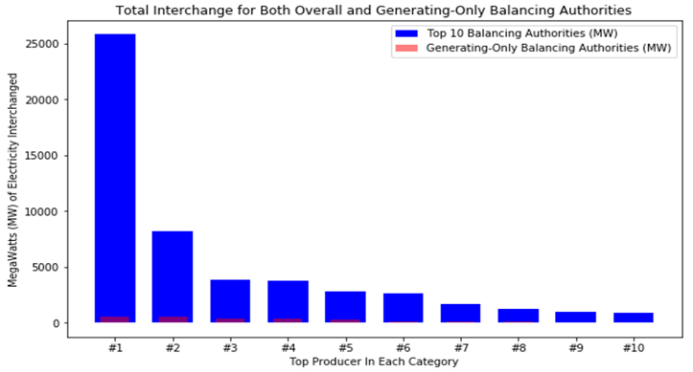

**Figure 1**

**Questions**

**Question 1**

Even with the discussed data issues, we found satisfactory answers to each of our research questions. Our response to question 1 demonstrates this trend. When examining which BAs exhibit negative interchanges during select hours, weekdays, and seasons, we started with hourly analysis. Figure two shows the hourly total interchange of the top 5 BAs with negative interchanges. As one can see, with the NYIS and PGE BAs the negative total interchange increases during daylight hours with more energy being consumed without compensating net generation. Conversely, with the MISO and ISNE BAs, the total interchange slightly decreases during daylight hours. Of the top 5 BAs with negative interchanges, CISO is the outlier with negative total interchange precipitously dropping during the daytime. Reserving speculation about what causes these swings for broader time periods, we are satisfied that the peaks and troughs of total interchange are visible to us, showing how successful or not successful each BA was in compensation for its user’s demand.

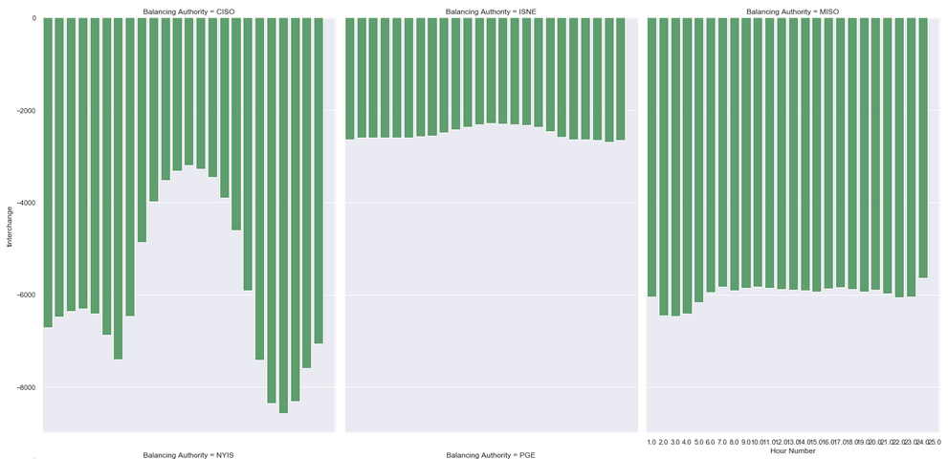

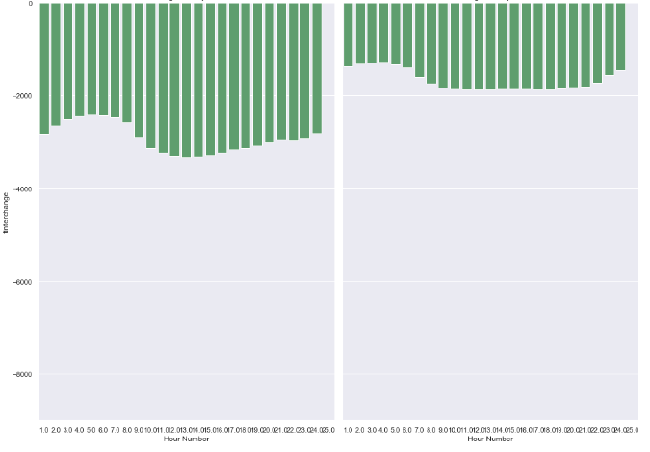

**Figure 2**

Continuing our investigation, we next examine daily demand. Figure 3 shows the average daily total interchange for each day of the week. Despite varying slightly, the average daily total interchange does not significantly change for the ISNE and NYIS BAs. However, the CISO, MISO, and PGE BAs possess rising negative total interchange towards the center of the week. Energy sources that can rise and fall to counteract such changes might help in bringing these BAs to a more positive total interchange and, therefore, more resilient state.

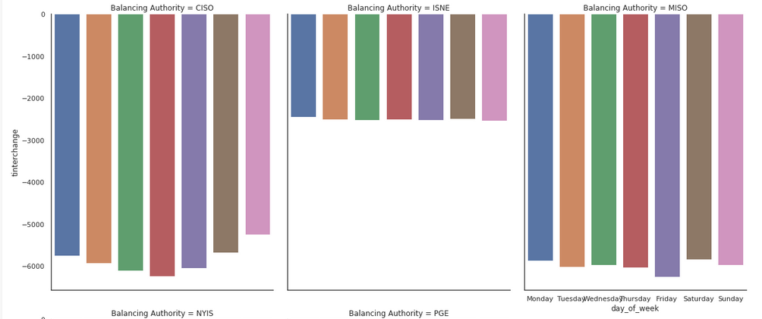

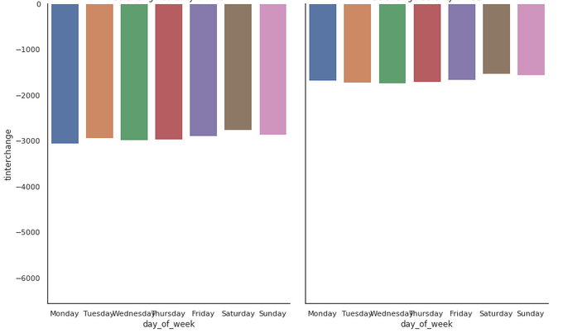

**Figure 3**

Seasonally, figure 4 shows a greater variance in the average total interchange than common at shorter analysis levels. Each examined BA shows quarters in which the average total interchange significantly rises and falls. Given the geographic dispersion of these BAs and the quarters in which total interchange is relatively higher or lower, we believe this discrepancy to be the result of climate. According to the U.S. Environmental Protection Agency, heating and cooling account for 43% of the average home’s electric bill (Bailey, 2016). This statistic easily accounts for the shifts in total interchange observed.

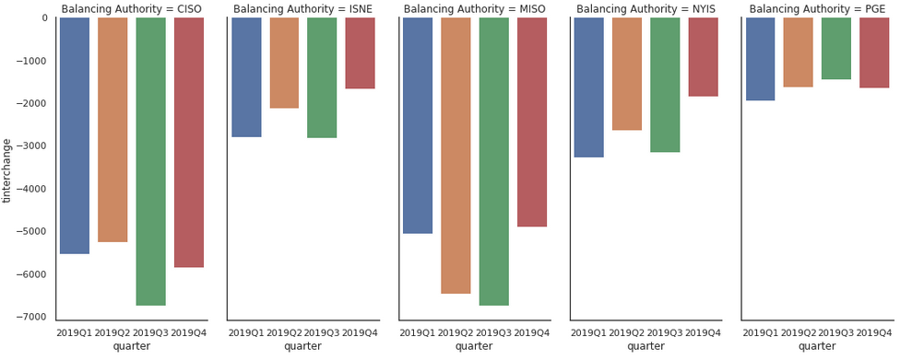

**Figure 4**

Characterizing our results for question 1 is a lack of consistency across BAs. The only constant is that the deficit for each total interchange will need to be individually addressed. Tailored solutions for the hourly, daily, and seasonal differences in negative total interchange will be needed. However, our answer to question 1 points to when the need for increased production is needed most in each BA.

**Question 2**

Moving on, we now examine how the top 10 BAs with positive interchanges and the top 10 BAs with negative exchanges compare in terms of their overall demand, excess or deficient capacity, and their favored energy generation sources. Figure 5 shows the raw mean MW per hour of total interchange, demand, and net generation for the top 10 BAs with positive total interchanges. This chart shows the scale of these BAs with 8 of the 10 exhibiting total interchange, demand, and net generation variables well below 1000 MWs per hour. No discernable common theme between larger and smaller BAs is obvious with the exception that all maintain a greater net generation than demand.

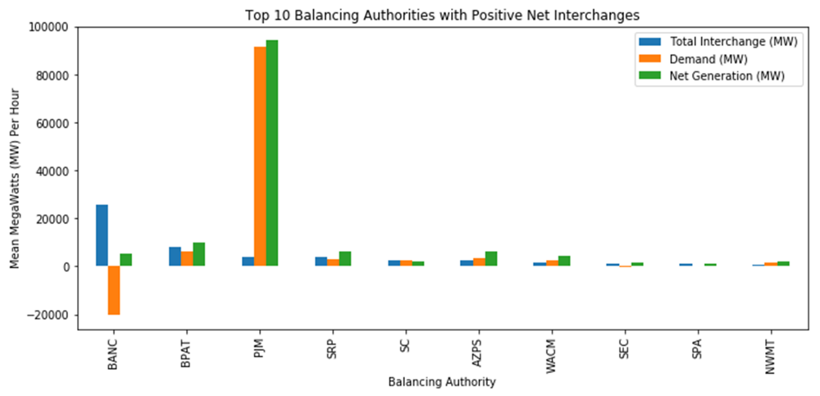

**Figure 5**

A more significant chart is figure 6, demonstrating the proportion of total interchange to net generation and demand, respectively, in the top 10 BAs with positive total interchanges. With almost all the included BAs, there are very high proportions of exported total interchange relative to both demand and net generation. 6 of the 10 entries have a positive total interchange equivalent to between 60% and 130% of their demand. Moreover, 2 of the 10 listed BAs export a positive total interchange equivalent to approximately 10 times their demand. Similar results occur when considering net generation with 8 of the 10 BAs exporting a positive total interchange equivalent to over 35% of their net generation. The BANC BA exports the most with the equivalent of almost 5 times their net generation exported. These figures indicate to us that the top 10 BAs with positive total interchanges specifically gear their power generation towards the export market instead of incidentally selling excess capacity.

A screenshot of a cell phone

Description generated with very high confidence

**Figure 6**

A similar story appears when considering the top 10 BAs with negative total interchanges. Figure 7 shows the scale of these BAs progressively rising as their negative total interchange becomes larger. No obvious conclusion can be reached with this data except that there appears to be some systematic inability or unwillingness for net generation to meet demand requirements.

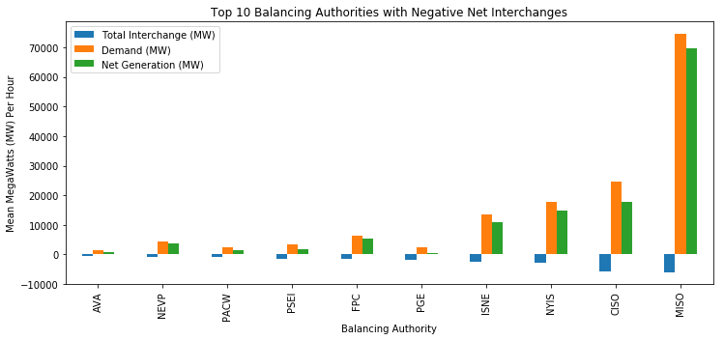

**Figure 7**

The picture becomes clearer when considering the ratio of total interchange to, respectively, demand and net generation. Figure 8 displays the proportion of total interchange to these two factors. Although the y-axis indicates that the scale is smaller than that exhibited by the top 10 BAs with positive total interchanges, the chart’s observations are still significant. 9 of the top 10 BAs with negative total interchanges import an amount of electricity at least equivalent to 20% of their demand.  As with the top 10 BAs with positive total interchanges, this indicates structural relationships between exporting and importing BAs that moves beyond periodic exchanges.

A screenshot of a cell phone

Description generated with very high confidence

**Figure 8**

Despite these patterns of apparent structure, only modest evidence exists of a set of energy generation sources that provide an advantage to either set of BAs. Figures 9 and 10 show the energy generation sources for the top 10 BAs with positive interchanges and the top 10 BAs with negative interchanges, respectively. Each set of BAs have similar mixes of energy generation sources. However, importing BAs tend to possess energy sources that exhibit more fossil fuels, such as natural gas, coal, and oil, as opposed to exporting BAs, which had stronger concentrations of cleaner energy sources such as nuclear, hydropower, and pumped storage (Nunez, 2019). Likewise, the spread of these energy generation sources is also close, but distinct. The top 10 BAs with positive interchanges have a 28.70% average standard deviation over all energy sources for each BA compared to a 25.54% average standard deviation for the top 10 BAs with negative interchanges.  These slim margins indicate a modest, more focused preference for cleaner energy sources by BAs with positive energy sources when compared to BAs with negative interchanges.

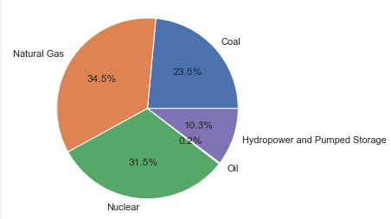

**Figure 9: The Energy Mix of the Top 10 BAs with Positive Interchanges**

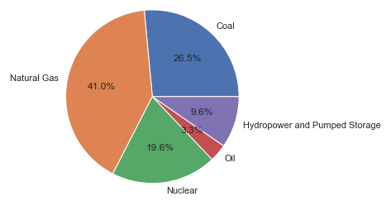

**Figure 10: The Energy Mix of the Top 10 BAs with Negative Interchanges**

Sadly, our results for question 2 define the problem, but not entirely how to fix the problem. Economic, regulatory, or some other forces drive select BAs to be exporters or importers. The proportions of electricity imported or exported make this observation almost certain. However, only a marginally greater focus on cleaner energy generation sources appears with the top 10 exporters over the top 10 importers.

**Question 3**

Our answer to question 3 might allow us to answer question 2. In question 3, we asked what are the top 5 BAs and regions for each available energy generation source. To answer this question, we grouped the dataset by BAs and took only the mean value of each variable. In addition to this, we also added the approximate latitude and longitude for each region so they can be used to visualize the data on a geographical map for later use. Figure 11 contains the top 5 BAs and their respective total interchanges, demands, net generations, and energy generation sources. Figure 12 expands the same criteria to the wider regions and color codes each region.

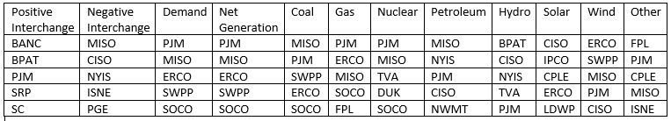

**Figure 11**

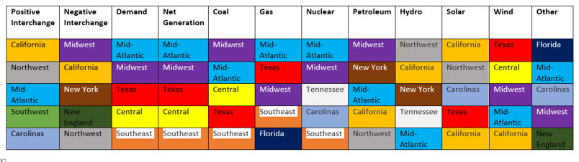

**Figure 12**

Question 3’s answer provides some patterns for importing BAs to emulate. The region with the greatest positive interchange, California, leads in several categories, including solar, hydro, and wind generation. Moreover, the second largest positive exporter, the Northwest region, is in the top 5 in the hydroelectric, solar, and petroleum generation categories. The Mid-Atlantic region likewise appears in the coal, gas, and nuclear categories. As the regions are made of BAs, similar patterns can be found in figure 11. These indicators demonstrate that, at an individual level, some of the greatest regional electrical exporters have, relative to their peers, specialized tendencies towards select power generation sources that are not obvious at more macro levels of analysis. Why these tendencies exist may be due to any number of economic, regulatory, or climate factors, but they are evidently highly individualized to each region.

**Question 4**

The impact of these specialized sets of energy sources becomes clearer when answering our question 4. In regions with more than one BA, we attempted to see if there is a pattern of positive or negative interchanges. To answer this question, we found the total interchange range for all BAs in each region with more than one BA and scrutinized any trends found therein. Figure 13 is the basis for our investigation. The regions are ordered by the combined regional total interchange with California as the first entry because it possesses the largest positive regional total interchange. As one can see from figure 13, multiple outliers, in both positive and negative directions, appear in several regions with most BAs clustering between – 1000 MW and 1000 MW.

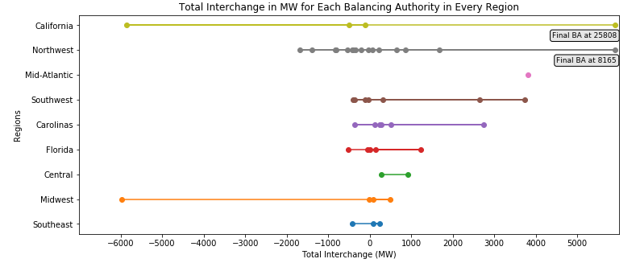

**Figure 13**

These trends implicate multiple patterns. First, the outliers appear to disproportionally swing the overall total interchange for each region. California is an example of this trend, with the largest BA overshadowing the much smaller total interchange values of other BAs. This observation could be connected to our answer to question 2 with BAs possessing more extreme positive or negative total interchanges possibly being so due to structural export or import relationships. Next, the clustering of BAs between -1000MW and 1000MW could indicate a natural business or regulatory boundary to greater growth. Only BAs with neighbors requiring significant imports could have the opportunity to exploit those deficiencies for expansion.

**Question 5**

Directly impacting a BA’s ability to expand is how energy production from a given energy source fluctuates throughout each day, week, and month. This inquiry is the focus of our question 5. Figures 14, 15, and 16 display our results from the 5 largest BAs that derive net generation from coal. On a weekly basis, these BAs produce consistent amounts of electricity from coal until the weekends, where generation slips for most producers. This difference could be because of the reduced need for power at work places. Monthly and seasonal figures tell a separate, but complimentary story. Figures 15 and 16 indicate dips in electrical production from coal during the spring and the fall with corresponding peaks in the winter and summer. As referenced before, these differences are most likely due to different heating and cooling requirements during more extreme temperatures.

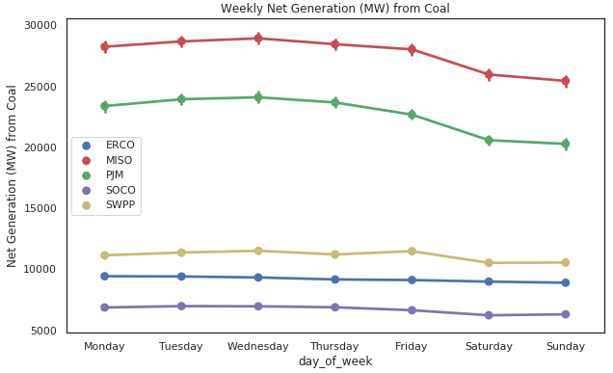

**Figure 14**

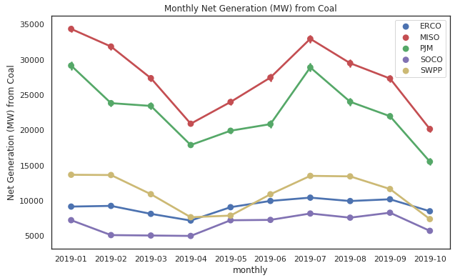

**Figure 15**

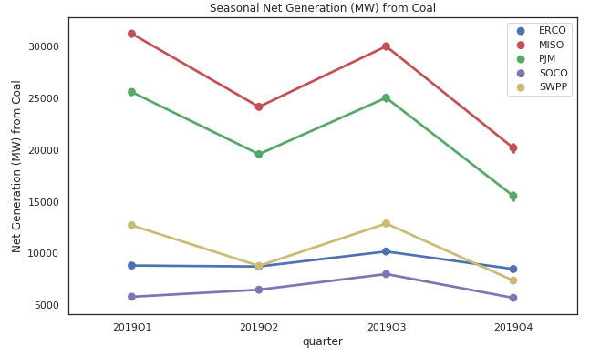

**Figure 16**

Electricity generated from natural gas and petroleum tells a very similar story as told by electricity generated from coal. Figures 17 through 22 detail this information. Weekend slackening in power generation is matched by seasonal power generation fluctuation likely due to the need for building temperature control. The close comparison found with these energy sources is probably due to the commodities used to produce their respective outputs. Coal, natural gas, and petroleum production are all entirely controlled by the power plant operators and their regulatory environment. Unlike solar or geothermal power, fossil fuel power plant owners have an obvious incentive to limit production to what is necessary as unnecessary coal, natural gas, and petroleum use consumes commodities that can be expended later.

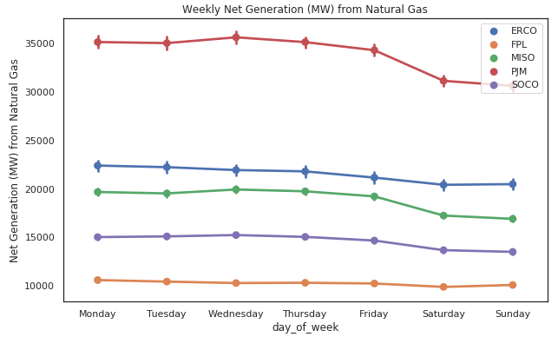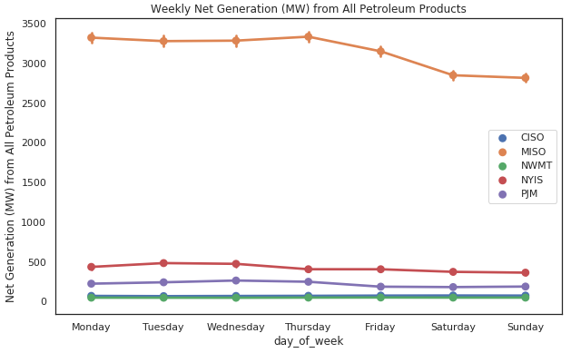

Figure 17 Figure 20

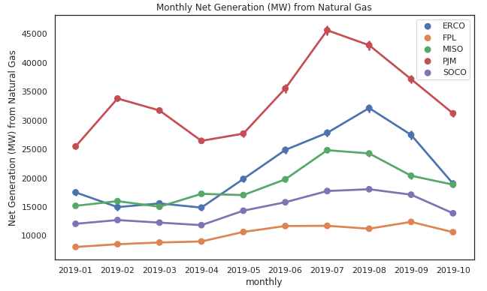 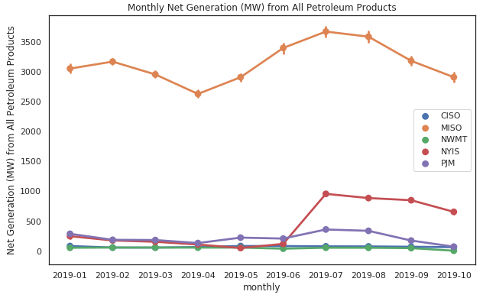

Figure 18 Figure 21

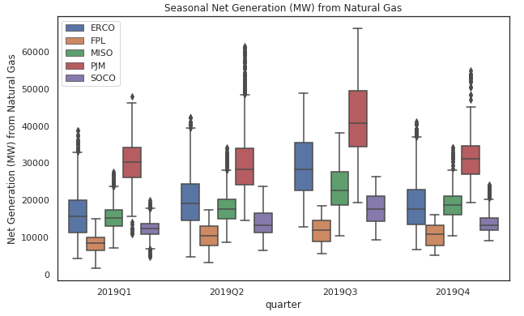 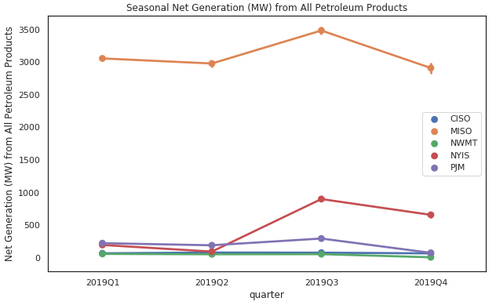

Figure 19 Figure 22

Less extreme fluctuations are present when considering nuclear power generation. Figures 23, 24, and 25 show how weekly average net generation is essentially consistent across all weekdays and fluctuates much less over the seasons than coal or natural gas. Given that nuclear reactors have lower overall operational costs than fossil fuels, shutting them down when demand slackens may be less appealing (U.S. Energy Information Administration, 2019). Furthermore, nuclear energy emits a fraction of the carbon emissions of either coal or natural gas, aiding in efforts to fit within environmental guidelines (Viaspace, 2019). Ergo, for economic and regulatory reasons, cutting nuclear power generation might be less attractive than cutting more disposable sources of energy.

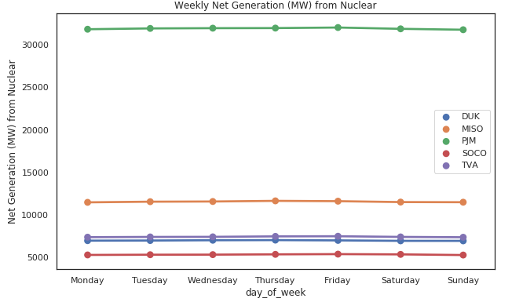

**Figure 23**

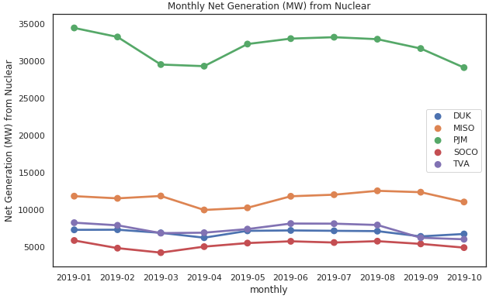

**Figure 24**

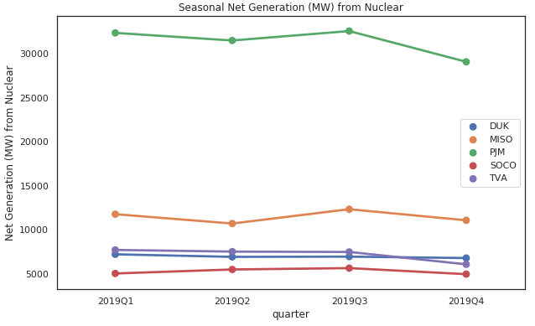

**Figure 25**

Figures 26, 27, and 28 show that hydropower and pumped storage electrical generation follow a similar pattern to nuclear electrical generation. Although there is a slight decrease in power generation over the weekend, the overall amount generated remains generally consistent. Seasonal patterns are also more constant than with commodity-based energy sources, but slightly less so than with nuclear energy. Hydropower and pumped storage power generation appears to peak in the second quarter, between April and June. This could be because water runoff from melting mountain snowfall increases the amount of water available for electricity generation in select times of the year (Pelto, 2019).

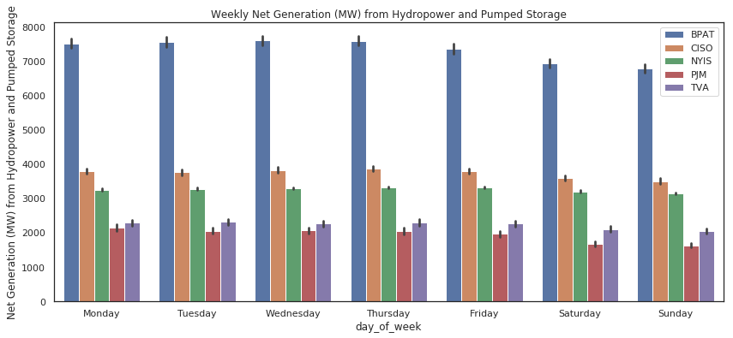

**Figure 26**

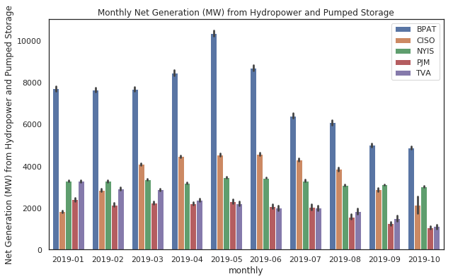

**Figure 27**

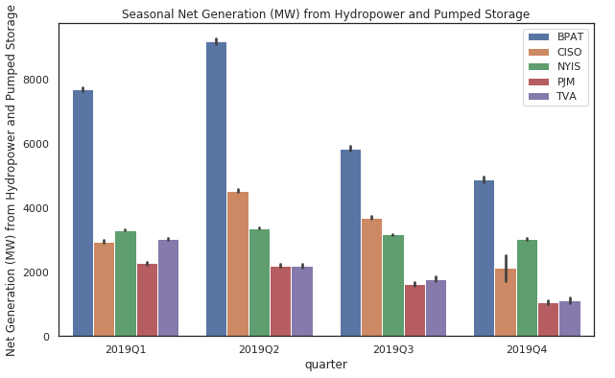

**Figure 28**

A similar natural phenomenon is noticed with wind and solar energy, albeit in a more extreme fashion than with the previously-mentioned energy sources. Figures 29 through 34 display relatively consistent solar and wind generation during the week. However, seasonal variations in the amount of sun available as well as changing wind patterns strongly influence the amount of electricity produced from each source. For solar, the winter months show a sharp decrease in power generation when compared to peak power generation in June. Likewise, wind energy appears to peak in April and October with relative dips in the winter and late summer.

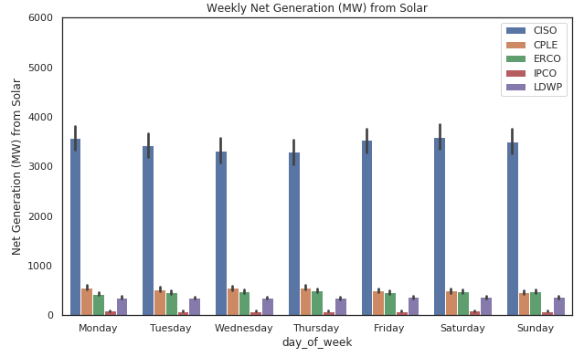 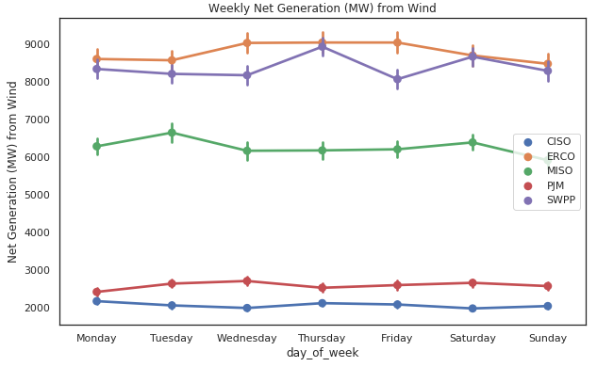

**Figure 29 Figure 32**

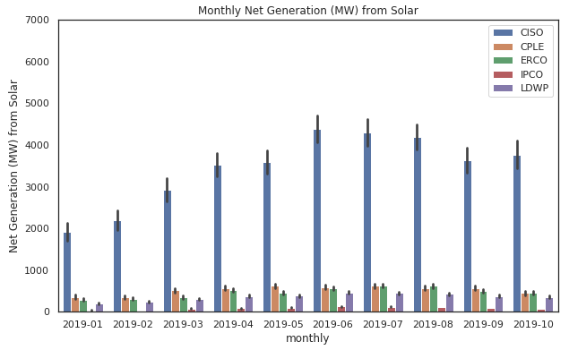 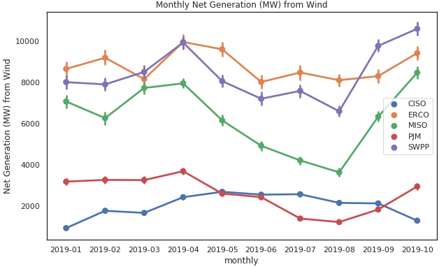

**Figure 30 Figure 33**

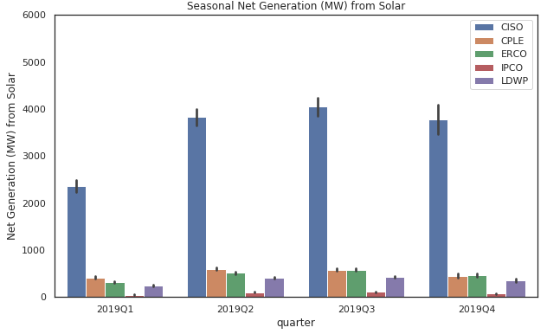 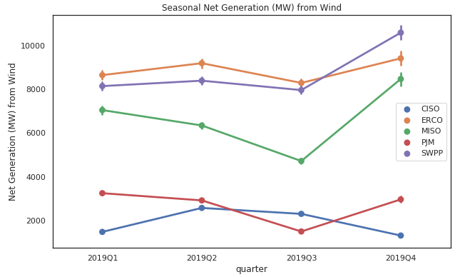

**Figure 31 Figure 34**

The takeaway from the examination of each energy source is that variety is key. Renewable energy resources such as wind, solar, hydropower, and geothermal have patterns that affect their utility at different times of the year. Conversely, commodity-based energy from coal, natural gas, and petroleum may be more flexible, but these energy sources are also highly dependent on market prices to continue producing electricity. Nuclear energy might be clean and reliable, but it faces heavy regulation. Any energy solution for a BA with negative total interchange will have to balance their respective economic, regulatory, and natural environments in order to determine how to effectively produce more electricity.

**Question 6**

Identifying which regions are most suitable for using renewable energy resources is the capstone of our investigation. Our question 6 asks which specific regions with consistent negative interchanges have high potential for supplemental solar or wind energy installation. First considering hydroelectric power, we find a portion of the U.S. already capitalizing on their natural resources. The Northwest region of the United States thrives in hydroelectric generation. The state of Washington alone generates over 22% of the country’s total hydroelectric power (U.S. Energy Information Administration, 2019). The main reason for this is the presence of the Columbia River which runs through the states of Washington, Oregon, and Idaho. Although the Columbia River Basin provides more than 40% of total U.S. hydroelectric generation, the cold weather in the winter freezes most of the river basin, largely preventing use during this season (Patel, 2019). At the same time, winter also brings an increase in electricity demand throughout the Northwest region. Unfortunately, as a result of these factors, this region faces a high demand and a shortage of energy generation during certain months of the year that cannot be fulfilled by the most obvious natural resource available.

Exploration of solar power generation offers another, slightly more viable solution. Figure 35 below contains maps displaying a side-by-side comparison of the top 5 BAs with negative interchange and the amounts of solar irradiance received throughout the U.S. 4 out of the 5 BAs with a high inflow lie on the regions with low solar irradiance. CISO in the California region is the only listed BA with a very high negative interchange that also falls within a high irradiance zone. Even though California leads solar power-based electricity generation with 739 solar power plants currently operating, we suggest more to meet local demand (State of California, 2019). While 739 solar power plants may seem like a great deal, the CISO BA still borrows large amounts of power from adjacent BAs to meet its energy needs. If local solar power plants are not feasible for CISO or any of the other listed BAs, large amounts of other western states such as Utah, Arizona, New Mexico, Colorado, Texas, and Oklahoma also receive high amounts of irradiance throughout the year. Structural relationships between BAs in these areas and poorer performing neighbors should be explored to help alleviate their energy deficit in a sustainable manner.

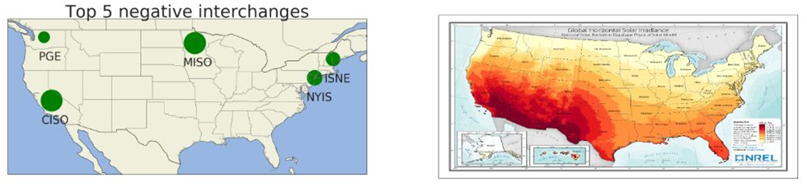

**Figure 35**

Moving onto wind power, we found a similar story. In figure 36, the map on the right image shows the annual average wind speed received at a height of 80 meters (m) above ground. Most utility level wind turbines have rotors at a height anywhere between 25m and 100m above the ground and they require an average wind speed of 6.26 m/second (Office of Energy Efficiency & Renewable Energy, 2019). Based on this fact, most of the regions marked in orange, brown, violet, and dark green are suitable for utility scale wind farms. This side-by-side comparison between the top 5 regions in terms of net generation using wind energy and the annual average wind speed map shows a clear view of how 3 out of 5 top 5 BA's are located in the middle portion of the country, which also happens to be the region with the most wind power. Our suggestion to help meet demand in the Midwest is to set up more wind farms in the states of North Dakota, South Dakota, Iowa, Nebraska, and Wisconsin. As seen in the previous figure 35, these regions do not receive high solar irradiance like southwestern U.S. states. However, they have a good average wind speed suitable for industrial scale wind farms. Utilizing this natural resource by building more wind farms outside the major mid-western cities could contribute to solving their negative interchange problems.

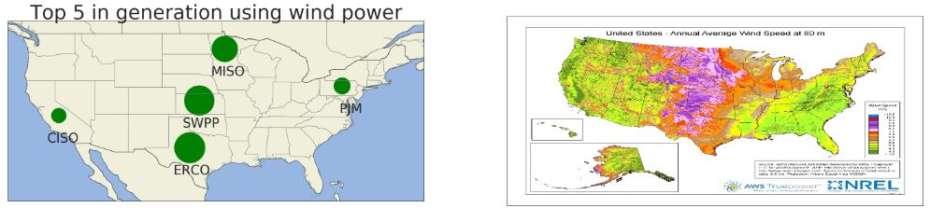

**Figure 36**

**Final Thoughts**

**Future Research**

To reinforce our findings, we suggest several improvements to the availability of data we believe strongly influences observed patterns. More precisely defining the boundaries of regions and BAs would allow future groups to precisely apply the wind and solar data available through the EIA.  Confirming with BAs the exact causes of observed negative demand would also help in determining how those sources should be counted when considering relative total interchange.  By identifying the average power line distance from power generation sources to customers, the EIA could enable future research on optimal locations to place power generation sources.  Finally, more exact data concerning interchange partners would allow higher fidelity investigations as to the true pollution cost of electricity used in a region or BA.

**Conclusion**

In summation, we found many of the patterns for which we initially searched. Strong daily, weekly, and seasonal patterns exist in the rhythm of power generation. High degrees of interconnectedness exist between regions, possibly indicating long-term, structural import and export relationships between BAs. Small preferences for relatively cleaner energy sources can be found in the top 10 BAs with positive interchanges over the top 10 BAs with negative interchanges. While seemingly minor, these patterns are reinforced when examining the overall leaders in each energy source across both regions and BAs. We are therefore led to believe that appropriately introduced clean energy sources, such as solar and wind, have a place in balancing out the BAs dragging down total interchange in underperforming regions.

# References

Bailey, A. (2016, February 03). *Breaking Down the Typical Utility Bill*. Retrieved from Ask the Expert: https://www.energystar.gov/products/ask-the-expert/breaking-down-the-typical-utility-bill

DigitalGreenMedia, LLC. (2010, May 04). *What is a Megawatt and a Megawatt-Hour?* Retrieved from cleanenergyauthority.com: https://www.cleanenergyauthority.com/solar-energy-resources/what-is-a-megawatt-and-a-megawatt-hour

Hussein, A. (2019, October 8). *A Day Without Power: Outage Costs for Businesses*. Retrieved from Bloomenergy: https://www.bloomenergy.com/blog/a-day-without-power-outage-costs-businesses

National Renewable Energy Laboratory. (2019, November 02). *Solar Maps*. Retrieved from Geospatial Data Science: https://www.nrel.gov/gis/solar.html

National Renewable Energy Laboratory. (2019, November 2). *Wind Maps.* Retrieved from Geospatial Data Science: https://www.nrel.gov/gis/wind.html

Nunez, C. (2019, January 30). *Renewable energy, explained*. Retrieved from National Geographic: https://www.nationalgeographic.com/environment/energy/reference/renewable-energy/

Office of Energy Efficiency & Renewable Energy. (2019, November 14). *Small Wind Guidebook.* Retrieved from WINDExchange: https://windexchange.energy.gov/small-wind-guidebook

Patel, S. (2019, March 1). *Power Supplies in Pacific Northwest Tighten as Deep Freeze Grips Region.* Retrieved from Power Magazine: https://www.powermag.com/power-supplies-in-pacific-northwest-tighten-as-deep-freeze-grips-region/

Pelto, M. S. (2019, November 12). *Glaciers as Reservoirs*. Retrieved from North Cascade Glacier Climate Project: https://glaciers.nichols.edu/glacier-runoff-hydropower/

State of California. (2019). *California Solar Energy Statistics and Data.* Retrieved from California Energy Commission: https://ww2.energy.ca.gov/almanac/renewables_data/solar/index_cms.php

U.S. Department of Energy. (2019, November 16). *Grid-Connected Renewable Energy Systems*. Retrieved from Energy Saver : https://www.energy.gov/energysaver/grid-connected-renewable-energy-systems

U.S. Energy Information Administration. (2018, January 11). *EIA-930 Data Users Guide and Known Issues* . Retrieved from U.S. Electric System Operating Data: https://www.eia.gov/realtime_grid/docs/userguide-knownissues.pdf

U.S. Energy Information Administration. (2019, November 02). *About the EIA-930 data*. Retrieved from Hourly Electric Grid Monitor: https://www.eia.gov/beta/electricity/gridmonitor/about

U.S. Energy Information Administration. (2019, November 26). *Table 1.10.A. Utility Scale Facility Net Generation from Hydroelectric (Conventional) Power*. Retrieved from Electric Power Monthly: https://www.eia.gov/electricity/monthly/epm_table_grapher.php?t=epmt_1_10_a

U.S. Energy Information Administration. (2019, November 02). *Table 8.4. Average Power Plant Operating Expenses for Major U.S. Investor-Owned Electric Utilities, 2008 through 2018 (Mills per Kilowatthour)*. Retrieved from How much does it cost to generate electricity with different types of power plants?: https://www.eia.gov/electricity/annual/html/epa_08_04.html

U.S. Energy Information Administration. (2019, November 02). *U.S. Electricity Overview (U.S. Lower 48)*. Retrieved from Hourly Electric Grid Monitor: https://www.eia.gov/beta/electricity/gridmonitor/dashboard/electric_overview/US48/US48

Viaspace. (2019). *Biomass Compared to Fossil Fuels, Solar and Wind*. Retrieved from Viaspace: https://www.viaspace.com/biomass_versus_alternatives.php